Myles J Sartor
Matthew Griffin
STAT100-0121
12 September 2023
Problem Set 1
1a-1b-1c-1d.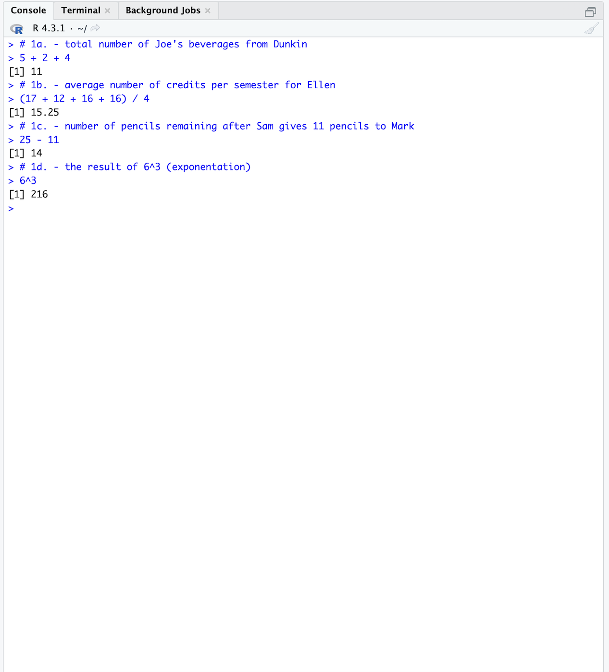

2a-2b-2c. 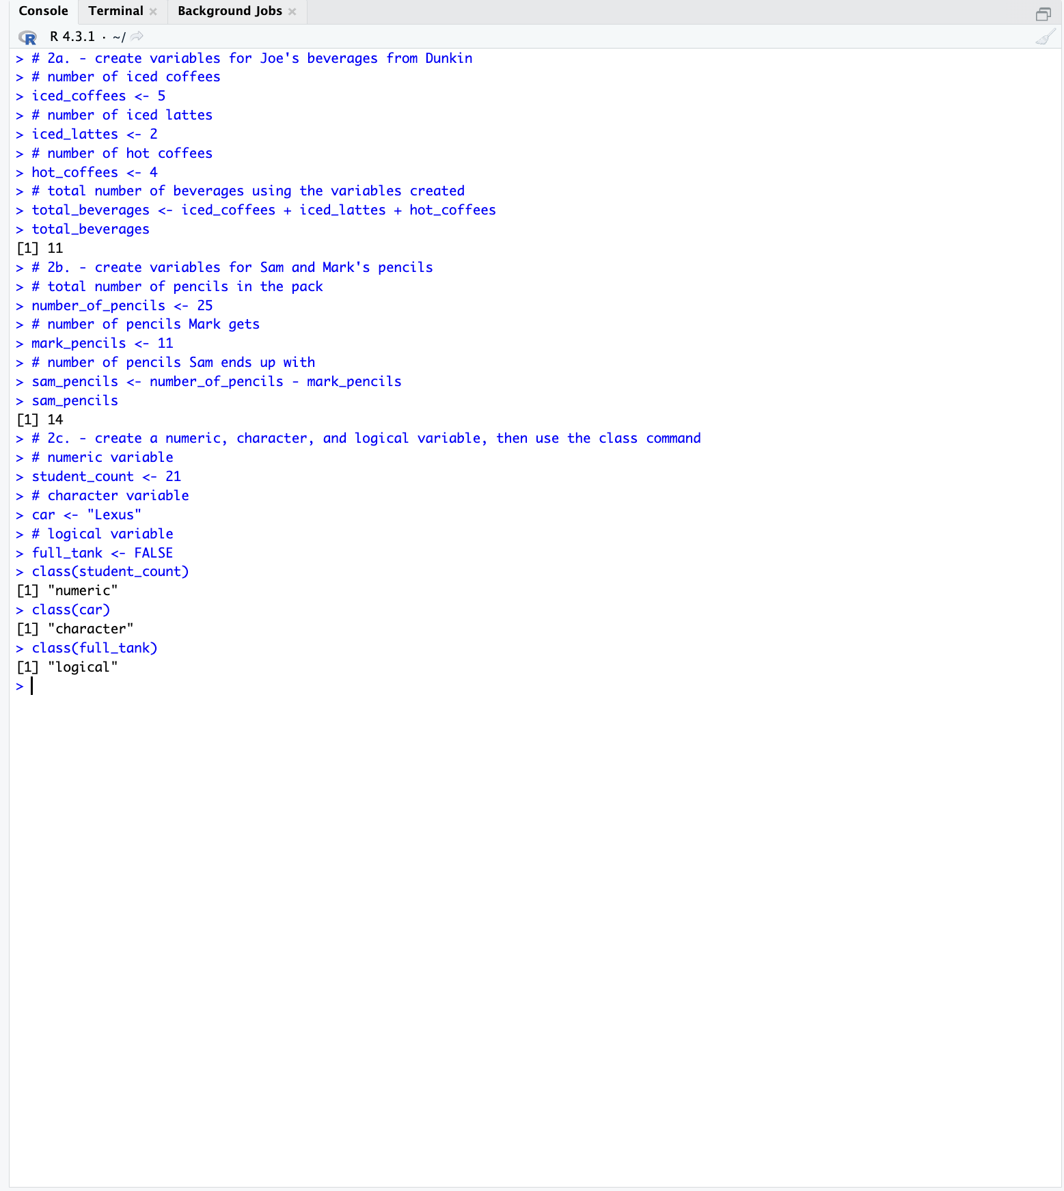
3a-3b-3c-3d-3e.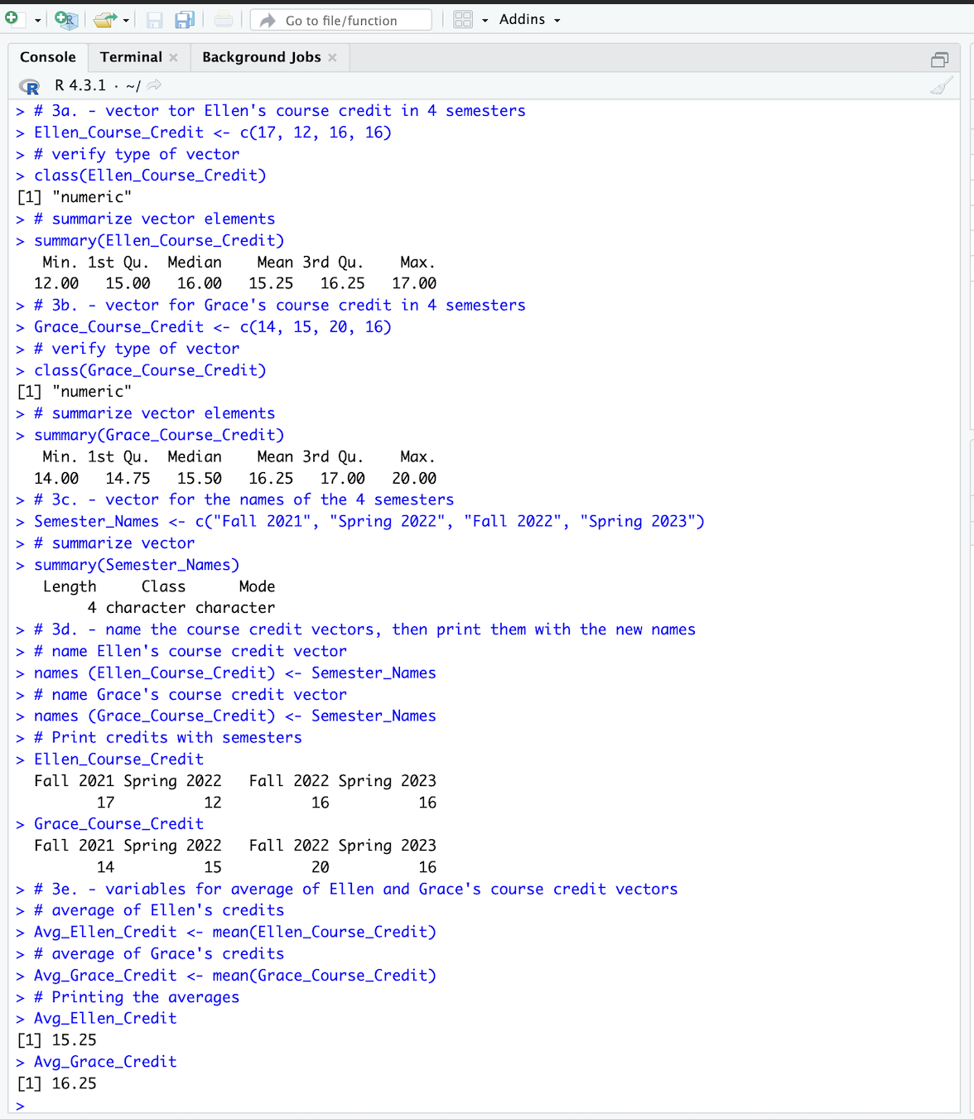
4a. 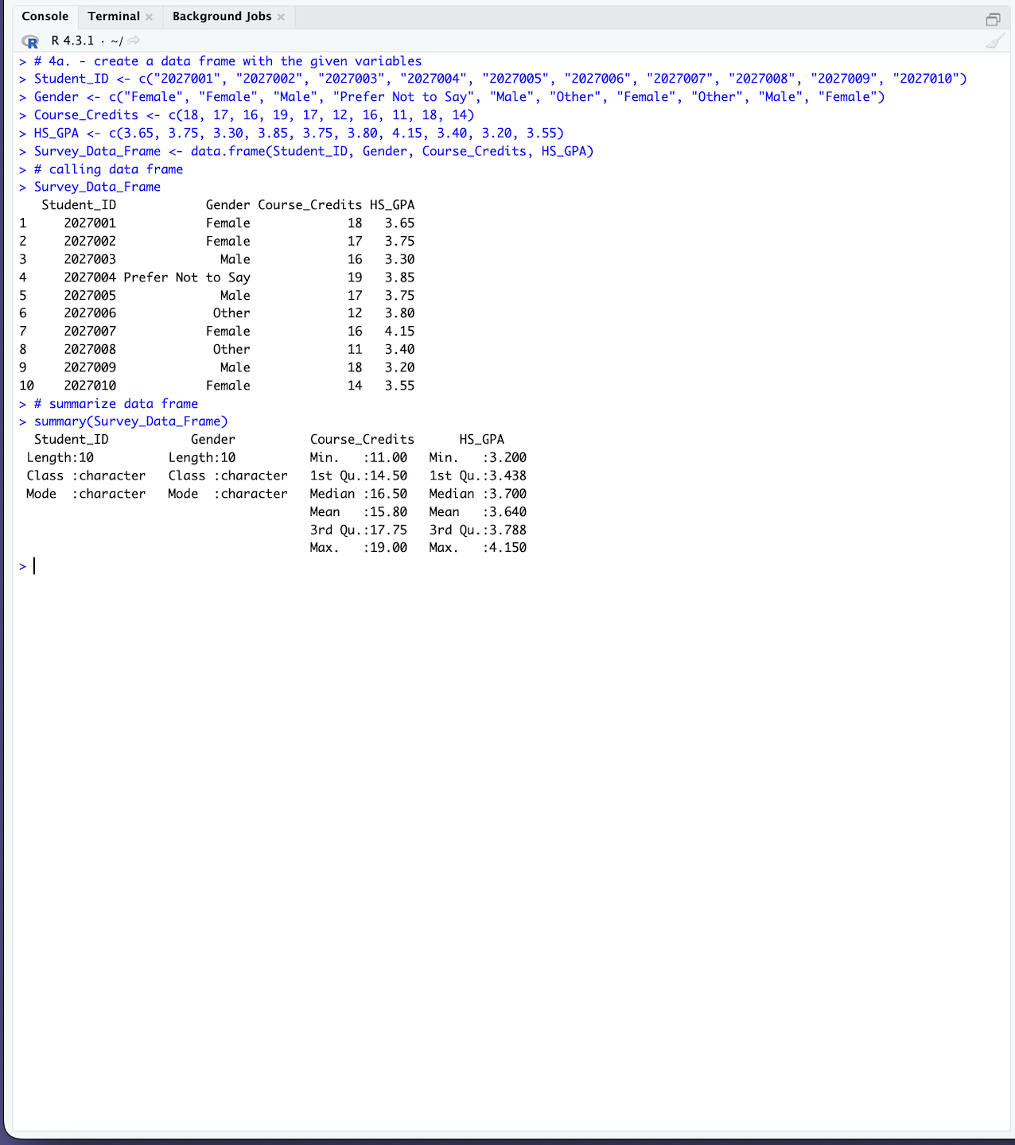

4b. (tabular form at the bottom)
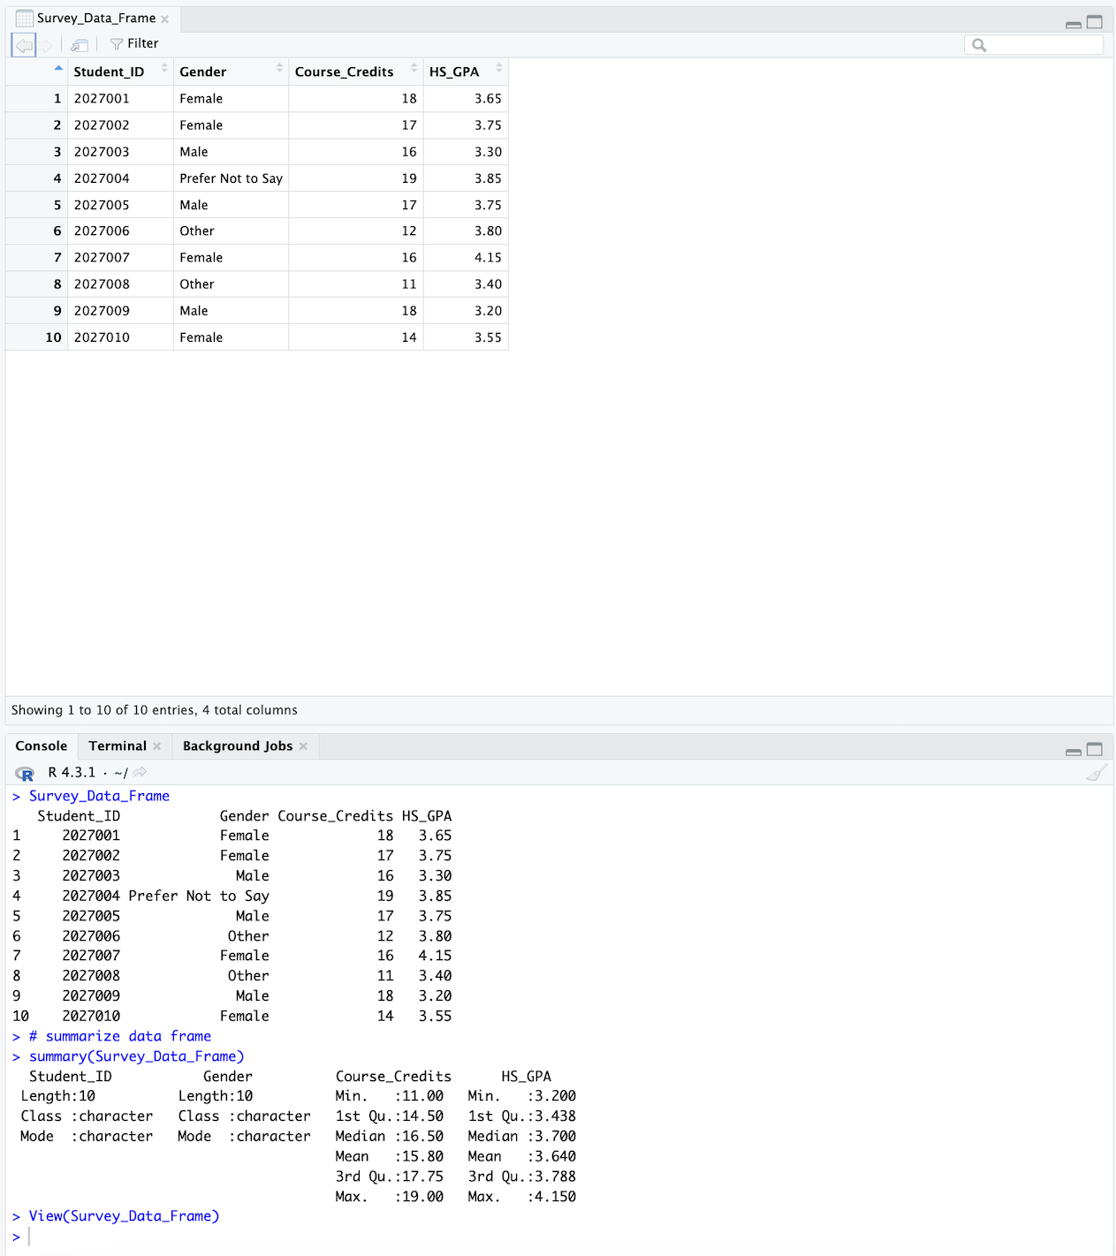
Student_ID |  | Gender |  | Course_Credits |  | HS_GPA
1 | 2027001 |  | Female |  | 18 |  | 3.65
2 | 2027002 |  | Female |  | 17 |  | 3.75
3 | 2027003 |  | Male |  | 16 |  | 3.30
4 | 2027004 |  | Prefer Not to Say |  | 19 |  | 3.85
5 | 2027005 |  | Male |  | 17 |  | 3.75
6 | 2027006 |  | Other |  | 12 |  | 3.80
7 | 2027007 |  | Female |  | 16 |  | 4.15
8 | 2027008 |  | Other |  | 11 |  | 3.40
9 | 2027009 |  | Male |  | 18 |  | 3.20
10 | 2027010 |  | Female |  | 14 |  | 3.55

